**Bitora Testing Report**

1. **When we check the bitora.in for responsiveness, there is a bug related to designing, which need to be solved.**

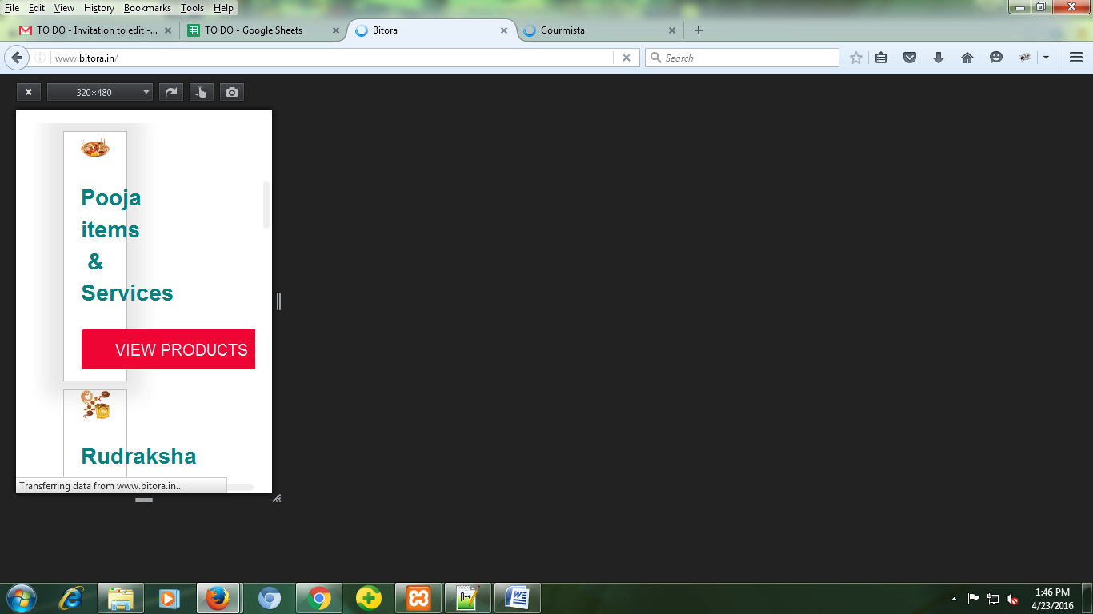

1. **At the footer there is another design issue related to responsiveness.**

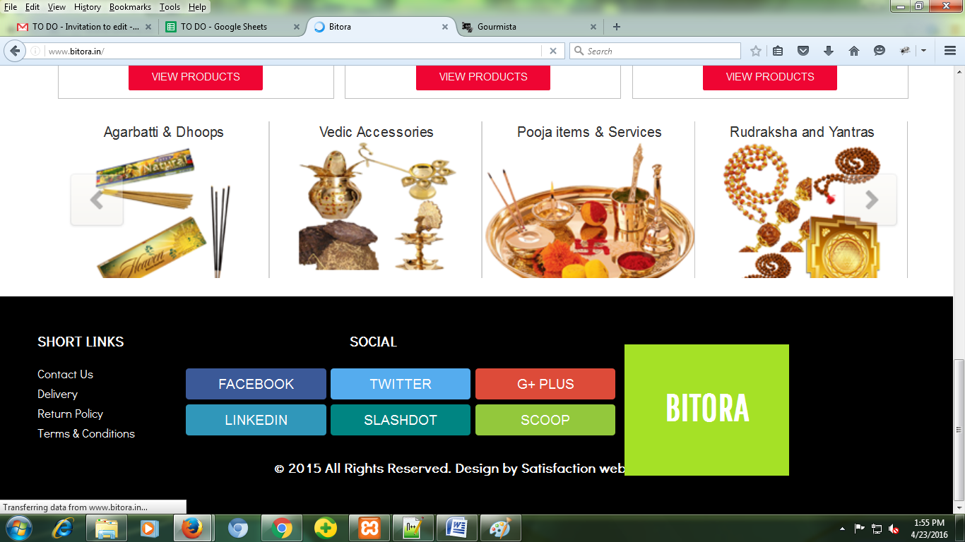

1. **Slider images on the home page are not of the same height and width, another design issue.**
2. **Bottom slider is not showing the images completely.**

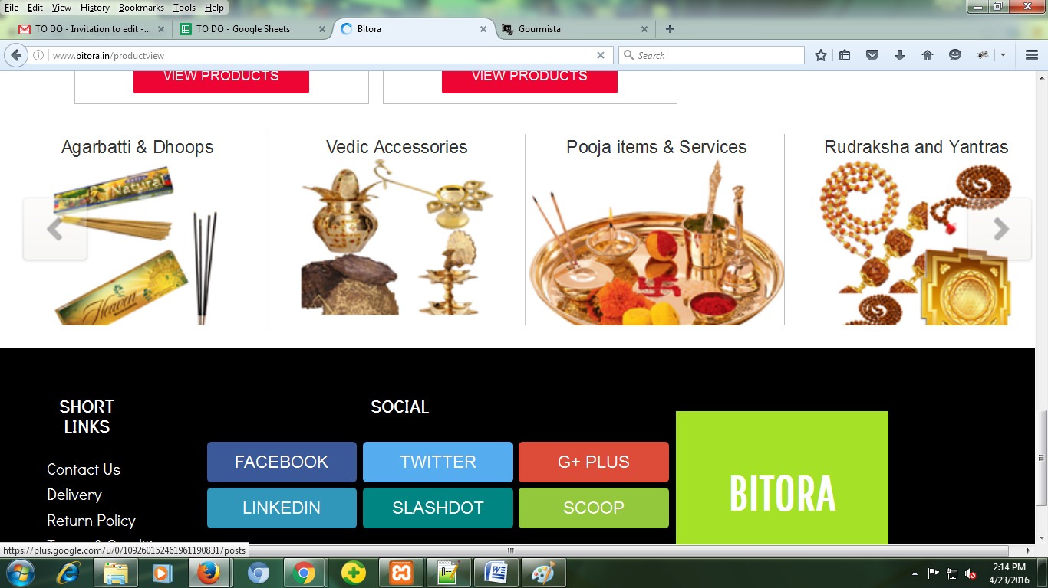

1. **Space between the menu and contact us text on contact us page.**

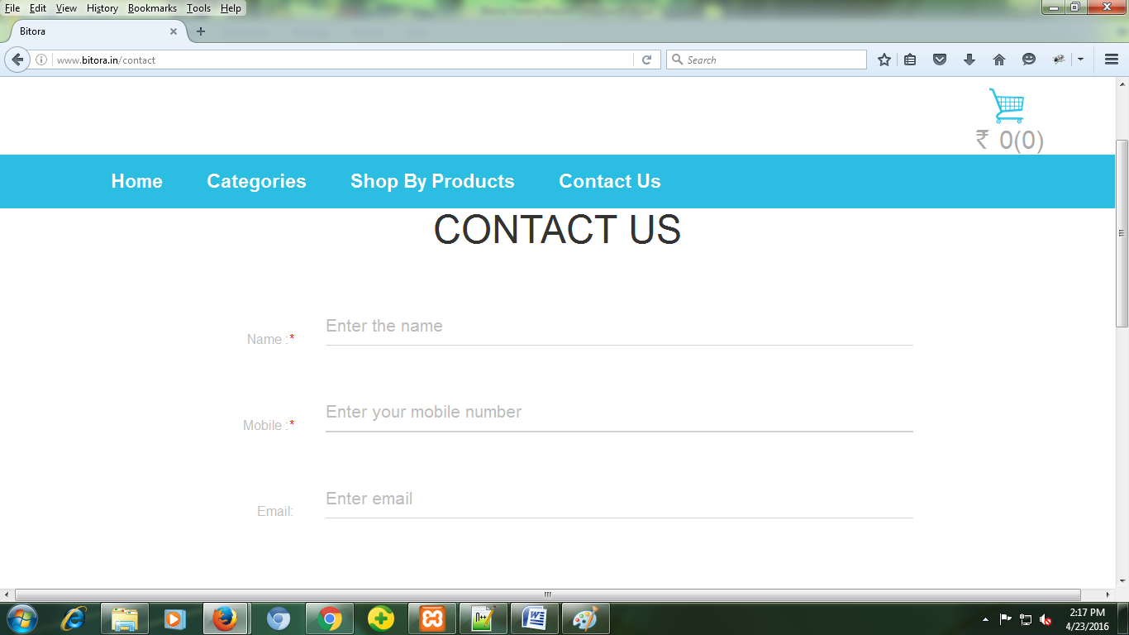

1. **On the footer page when a user clicks on the satisfaction web solution link, it doesn’t open the url in new tag but on the same page itself.**